TRACEABLE: Simple Guide to Our AI Visual Exploration for Building Deconstruction

1. Goal: What Are We Trying to Achieve?
In the TRACEABLE project, our objective is to help experts inspect buildings before deconstruction. We want to automatically detect salvageable components (doors, windows, radiators, structural elements) from everyday site photos.
To achieve this, we are exploring and comparing two different technical paths:
• Approach 1: The "Fixed Checklist" Method (teaching the AI to look only for a strict list of predetermined labels, like "door" and "window").
• Approach 2: The "Expert Building Auditor" Method (loading a flexible AI on our local machine and letting it inspect the room freely with no preset label list).
Approach 1: The "Fixed Checklist" Method (Predefined Labels)
How it works:
Imagine sending a surveyor onto a site with a rigid checklist that only contains two checkboxes: "Door" and "Window".
• The software cuts the image into separate items and compares every single piece strictly against those two choices.
• We can fine-tune or train the system so it gets very good at recognizing those specific items.
Benefits & Trade-offs in Plain Terms:
• The Good: Fast, creates very crisp outlines around objects, and easily slots into traditional pre-made database tables.
• The Catch:
- Rigid blind spots: If an object in the room is not on the list (e.g., stairs, ceiling panels,, or radiators), the system gets forced to pick the closest label on its checklist. This leads to mistakes like labeling walls or ceiling panels as doors.
- Heavy preparation needed: To teach the AI new items, humans must first manually draw boxes and label hundreds of photos by hand.
Approach 2: The "Expert Building Auditor" Method (Spark AI Assistant)
How it works:
Instead of restricting the AI to a predefined checklist, we run a large multimodal vision model locally on our computer and give it a professional role (an "AI Persona"):
"You are an expert structural engineer, circular construction surveyor, and building deconstruction auditor. Inspect this site photo, spot all salvageable elements, tell us what materials they are made of, whether they can be directly reused or refurbished, how they are fastened, and highlight any safety or environmental risks."
We do not need to pre-train or label photos beforehand. The AI reads the entire visual scene, examines visible hardware and markings, and writes an inspection report automatically.
Real-World Demonstration: A Single Survey Photo
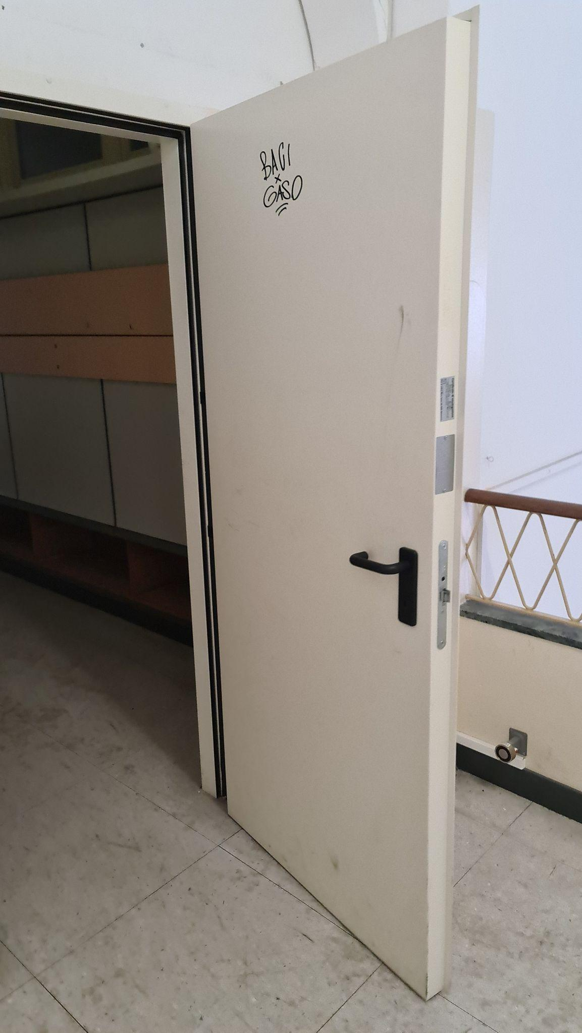
To show how this works in practice, we ran a photo of an interior corridor door (Image: 20240819_100055.jpg) through the local AI model without giving it any predefined labels.
The AI's Automatic Audit Report:

space_type: circulation corridor,
overall_condition: Fair
Salvageable_components: Doors & Portal, flush steel fire-rated estimated_materials: carbon steel, mineral core, paint coating,
hardware_present: black lever handle, mortise lock, strike plate, door closer (partially visible),
labels_or_markings: Graffiti: 'BAGI CASO' in black marker; two silver certification/label plates on edge (partially obscured, likely fire rating or manufacturer ID),
hazard_and_diagnostic_flags: Verify fire rating label content and core material (possible legacy asbestos-containing core in older buildings). Test for lead-based paint on door surface and hardware due to age and graffiti.

Why this matters for TRACEABLE:
• Unprompted Specificity: Without being told a door was present, it identified it specifically as a flush steel fire-rated door leaf, transcribed the handwritten marker graffiti ("BAGI CASO"), and detected the silver certification badge on the edge.
• Circular Economy Variables: inventoried fittings (lever handle, lock, closer)
• Actionable Dismantling & Safety Guidance: It highlighted practical deconstruction steps and flagged testing for lead paint and inspecting the core/sealants for hazardous materials.

Practical Recommendation: How We Combine Both
We don't need to choose between them; they work best together as a team:
1. First Pass (AI Auditor on Spark): Automatically scans survey photos, discovers elements, drafts material and reuse descriptions, and flags safety risks.
2. Human Validation: Our circularity surveyors quickly review and verify the AI's findings instead of typing an audit from scratch.
3. Outline Refinement: For approved items, we apply fast boundary-drawing tools to link them with exact geometry into the lightweight Digital Twin.

